American International University- Bangladesh (AIUB) Faculty of Engineering (FE)

|  |  |  |  |
| --- | --- | --- | --- |
| **Course Name:** | DATA COMMUNICATION | **Course Code:** | COE3103 |
| **Semester:** | Summer 2024-25 | **Section:** | D |
| **Faculty:** | MOHAMMAD ASADUZZAMAN KHAN | **Group:** | 05 |

|  |  |
| --- | --- |
| **Experiment No:** | 07 |
|  |  |
| **Experiment Name:** | **Study of Digital to Analog Conversion using MATLAB** |

|  |  |  |  |
| --- | --- | --- | --- |
| **Group Members** | | **Name** | **ID** |
|  | 1. | Basudeb Kundu | 23-50856-1 |
| 2. | Prohlad Chandra Das | 23-50922-1 |
| 3. | Debashis Kumar Das | 23-50953-1 |
| 4. | Indronill Dutta Nill | 23-50974-1 |
| 5. | Nafiur Rahman Nirob | 23-50991-1 |

|  |  |  |  |
| --- | --- | --- | --- |
| **Performance Date:** | 24-8-25 | **Due Date:** | 31-8-25 |

**Marking Rubrics (to be filled by Lab Instructor)**

|  |  |  |  |  |  |
| --- | --- | --- | --- | --- | --- |
| Category | Proficient [6] | Good [4] | Acceptable [2] | Unacceptable [1] | Secured Marks |
| **Theoretical Background, Methods & procedures sections** | All information, measures and variables are provided and  explained. | All Information provided is sufficient, but more explanation is  needed. | Most information is correct, but some information may be  missing or inaccurate. | Much information is missing and/or inaccurate. |  |
| **Results** | All of the criteria are met; results are described clearly and accurately; | Most criteria are met, but there may be some lack of clarity and/or incorrect information. | Experimental results don’t match exactly with the theoretical values and/or analysis  is unclear. | Experimental results are missing or incorrect; |  |
| **Discussion** | Demonstrates thorough and sophisticated understanding.  Conclusions drawn are appropriate for  analyses; | Hypotheses are clearly stated, but some concluding statements not supported by data or data not well  integrated. | Some hypotheses missing or misstated; conclusions not supported by data. | Conclusions don’t match hypotheses, not supported by data; no integration of data from different sources. |  |
| **General formatting** | Title page, placement of figures and figure captions, and other  formatting issues all correct. | Minor errors in formatting. | Major errors and/or missing information. | Not proper style in text. |  |
| **Writing & organization** | Writing is strong and easy to understand; ideas are fully elaborated and connected; effective transitions between sentences; no  typographic, spelling, or grammatical errors. | Writing is clear and easy to understand; ideas are connected; effective transitions between sentences; minor typographic, spelling, or grammatical errors. | Most of the required criteria are met, but some lack of clarity, typographic, spelling, or grammatical errors are present. | Very unclear, many errors. |  |
| Comments: |  | | | Total Marks (Out of **30**): |  |

**Title**

Study of Amplitude Modulator and Demodulator using MATLAB

# Abstract

This experiment is designed to-

1.To understand the use of MATLAB for AM modulation.

2.To develop understanding of AM demodulation.

**Introduction**

Amplitude modulation (AM) is a one of the conventional technique used to transmit message signals using a carrier wave. The amplitude or strength of the high frequency carrier wave is modified in accordance with amplitude of the message signal.

➢

**AM Modulation:**

**Fig1:**

**AM modulated signal in time and frequency domain.**

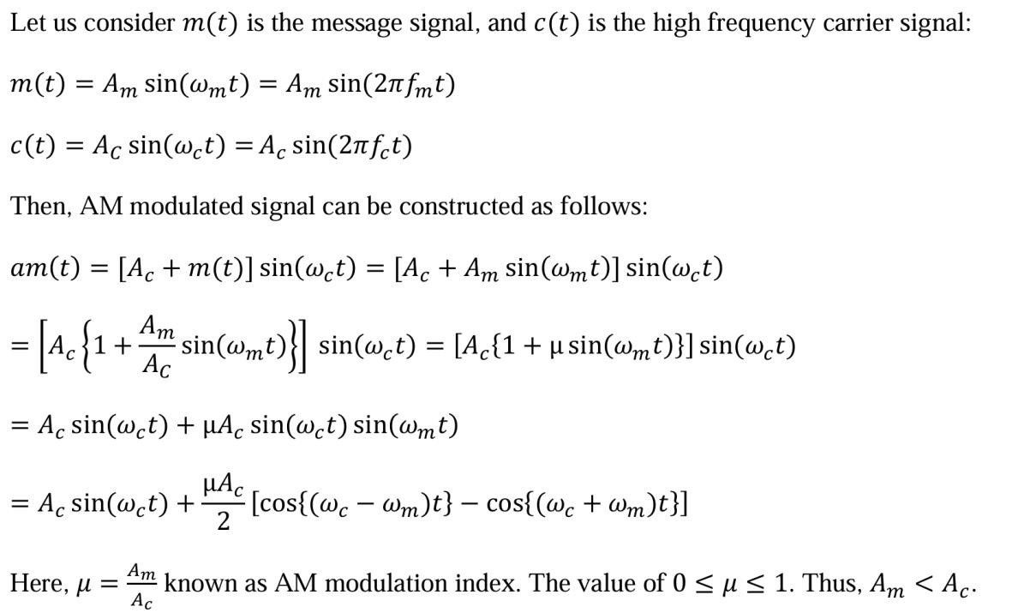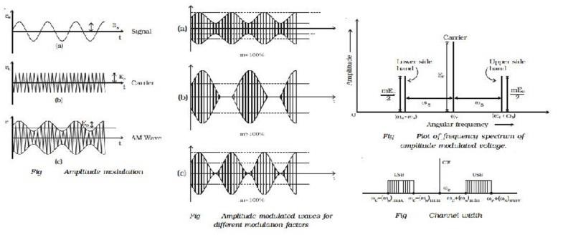

➢

**AM**

**D**

**emodulation:**

**Fig**

**2**

**:**

**AM demodulation process.**

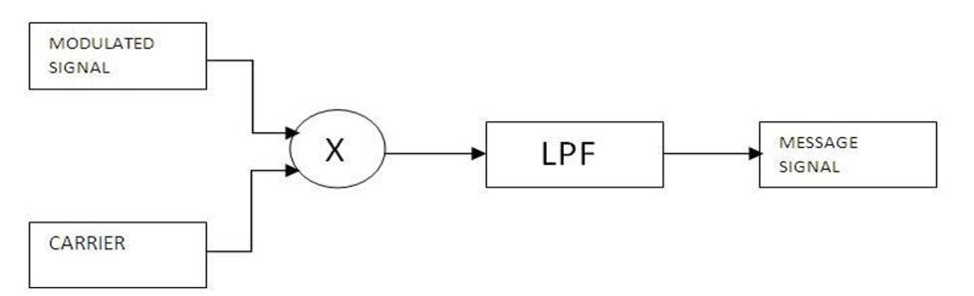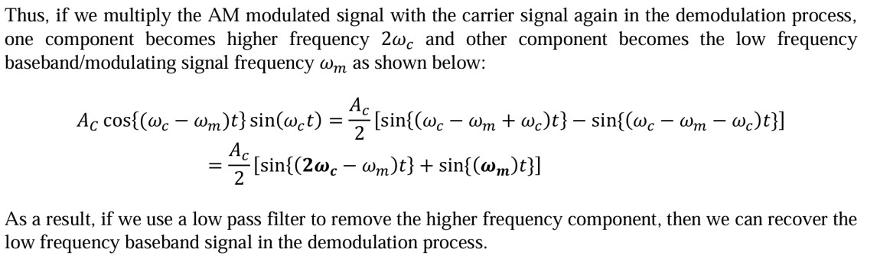

# Results and Discussion

1.Define modulation and AM modulation. Why modulation is necessary in communication

Ans. Modulation is the process of varying one or more properties (amplitude, frequency, or phase) of a high-frequency carrier signal in accordance with the information or message signal. It is a fundamental technique used in communication systems to transmit data over long distances.

Amplitude Modulation (AM) is a type of modulation in which the amplitude of the carrier signal is varied in proportion to the instantaneous amplitude of the message signal, while the frequency and phase remain constant.

**Why Modulation is Necessary in Communication**:

**Efficient Transmission**: Message signals (such as audio) usually have low frequencies and cannot be transmitted efficiently over long distances. Modulation shifts these signals to higher frequencies suitable for propagation.

**Antenna Size Reduction**: The size of a transmitting/receiving antenna is inversely proportional to the frequency. Modulating the signal onto a high-frequency carrier allows for practical antenna sizes.

**Multiplexing:** Modulation enables multiple signals to be transmitted simultaneously over the same channel using different carrier frequencies (frequency-division multiplexing).

**Noise Reduction**: High-frequency carriers are less susceptible to certain types of noise and interference.

**Long-Distance Communication**: Carrier waves can travel farther and more reliably than baseband signals.

2. Mathematically proved that for the message signal 𝑚(𝑡) = 𝐴𝑚sin(𝜔𝑚𝑡) and carrier signal

𝑐(𝑡) = 𝐴𝐶 sin(𝜔𝑐𝑡), AM modulated signal is a composite signal consisting of three frequency components. Then, produce the equation for Bandwidth for AM modulated signal.

Ans. Let the message signal be:

m(t) = Am × sin(ωm × t)

Let the carrier signal be: c(t) = Ac × sin(ωc × t)

The amplitude modulated (AM) signal is given by: sAM(t) = [Ac + m(t)] × sin(ωc × t)

= [Ac + Am × sin(ωm × t)] × sin(ωc × t)

Now expand the expression:

sAM(t) = Ac × sin(ωc × t) + Am × sin(ωm × t) × sin(ωc × t)

Using the trigonometric identity:

sin(A) × sin(B) = ½ × [cos(A − B) − cos(A + B)]

We substitute:

Am × sin(ωm × t) × sin(ωc × t) = (Am / 2) × [cos(ωc − ωm)t − cos(ωc + ωm)t]

Now substitute back into the main equation:

sAM(t) = Ac × sin(ωc × t) + (Am / 2) × [cos(ωc − ωm)t − cos(ωc + ωm)t]

From this result, we can clearly see that the AM signal consists of three frequency components:

Carrier frequency: ωc or fc

Lower Sideband (LSB): (ωc − ωm) or (fc − fm)

Upper Sideband (USB): (ωc + ωm) or (fc + fm)

**Bandwidth of AM Signal**

The bandwidth (BW) of an AM signal is the difference between the highest and lowest frequency components:

**BW = (fc + fm) − (fc − fm) = 2fm**

Where:

fm is the maximum frequency present in the message signal.

Therefore, the Bandwidth of an AM signal is twice the highest frequency of the message signal.

**3.** Write a MATLAB code to generate AM modulated and demodulated signal for baseband signal m(𝑡) = 20sin(10𝜋𝑡).

|  |
| --- |
| **Code** |
| **clc; clear;**  **fs = 3000; t = 0:1/fs:1-1/fs; fm = 5; fc = 100; Am = 20;**  **m = Am .* sin(2*pi*fm*t);**  **Ac = 40; c = Ac .* sin(2*pi*fc*t); mu = Am / Ac;** |

|  |
| --- |
| **cam = Ac .* (1 + mu .* sin(2*pi*fm*t)) .* sin(2*pi*fc*t); fftSignal = fft(cam);**  **fftSignal = fftshift(fftSignal) / (fs/2); f = fs/2 * linspace(-1,1,fs); am_demodulated = cam .* c;**  **[k, l] = butter(6, (100*2)/fs);**  **filtered_signal = filtfilt(k, l, (am_demodulated ./ 20) - 40);**    **figure; subplot(4,1,1); plot(t, m);**  **ylabel('Amplitude'); xlabel('Time (s)'); title('Modulating/Baseband Signal'); grid on;**    **subplot(4,1,2); plot(t, c);**  **ylabel('Amplitude'); xlabel('Time (s)'); title('Carrier Signal'); grid on;**    **subplot(4,1,3); plot(t, cam);**  **ylabel('Amplitude'); xlabel('Time (s)'); title('Amplitude Modulated Signal'); axis([0 1 -60 60]); grid on;** |
| **subplot(4,1,4); plot(t, filtered_signal);**  **ylabel('Amplitude'); xlabel('Time (s)'); title('Demodulated Signal'); axis([0 1 -20 20]); grid on;**    **figure;**  **plot(f, abs(fftSignal)); axis([0 120 0 40]);**  **title('FFT of AM Modulated Signal'); xlabel('Frequency (Hz)'); ylabel('Amplitude');** |

|  |
| --- |
| **Result and Discussion** |
|  |

The first plot shows the frequency spectrum (FFT) of the AM modulated signal. Distinct spectral components

appear at the

carrier frequency (

**100**

**Hz**

(

)

and at frequencies offset by the modulating signal’s frequency

**95**

**Hz**

**and 105 Hz**

)

. This confirms the theoretical expectation that an AM signal contains three primary frequencies

components: the carrier, upper sideband, and lower

sideband.

In the second section, the four time

-

domain plots illustrate the complete AM communication process:

•

**Top plot**

:

The modulating/baseband signal (message), which is a low

-

frequency sine wave of 5 Hz.

•

**Second plot**

:

The carrier signal, a higher

-

frequenc

y sine wave at 100 Hz that carries the information.

•

**Third plot**

:

The amplitude modulated (AM) signal. The envelope of this high

-

frequency carrier follows

the shape of the baseband signal, showing how information is embedded in the amplitude of the carrier.

•

**Fourth plot**

The demodulated signal, which closely matches the original baseband message, indicating

:

successful recovery of the transmitted information.

Together, these plots validate the AM modulation and demodulation process. The frequency

-

domain spectru

m

confirms the presence of carrier and sidebands, while the time

-

domain waveforms clearly show how the

baseband message is transmitted and then accurately reconstructed with minimal distortion

.

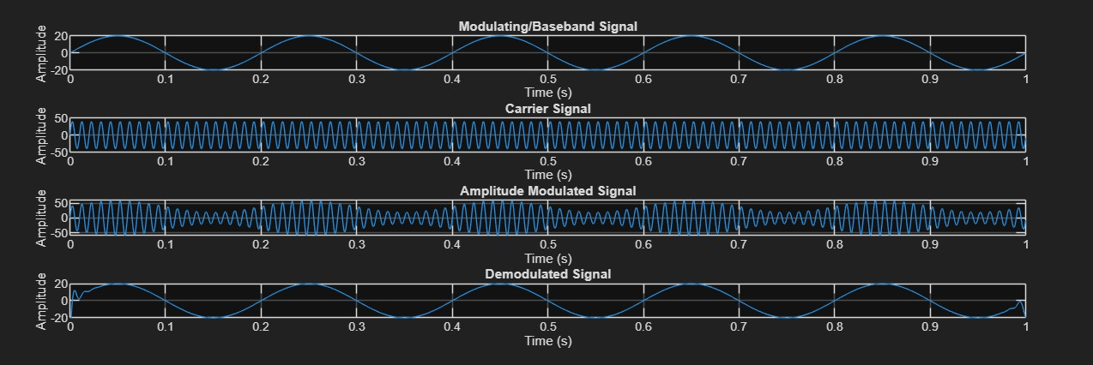

# Conclusion

The experiment successfully demonstrated amplitude modulation and demodulation using MATLAB. The results show that AM can efficiently transmit message signals and that demodulation can accurately retrieve the original information under ideal conditions. This simulation-based approach provided valuable insight into the fundamental principles of analog communication systems and reinforced theoretical concepts with practical visualization. Future experiments could involve noise addition and alternative modulation schemes to further deepen understanding.